
D O K U Z E Y L Ü L U N I V E R S I T Y
FACULTY OF ENGINEERING

COMPUTER ENGINEERING DEPARTMENT

Project Final Report

Course : CME1101 - Project Based Learning -1
Project No : Lab 3 Date: 10.12.2012
Project Name : Set Game

Prepared By : Group/Subgroup No:

Members: No: Name:
1. 2008510048 Anıl Teke
2. 2009510046 Ali Konya
3. 2009510103 Deniz Arslan
4. 2011510105 BerkayTürkgeldi

1. Project Description
Give summarized details about project; purpose and scope of the project, start and completion dates. Give any background information you have researched to complete the project.

The aim of the project is to construct 3-element set expressions and try to gain the highest score. The project finished in 3 weeks and then we started to preapre a presentation and poster. At the same time, we improved some properties in the project like adding various colours to make game clear.

2. Task Summary

2.1. Completed Tasks
Member | Task
Berkay Türkgeldi | Designing set operators, placing all sets and operator signs on board, if an expression contains two same set, do not do anything
Deniz Arslan | Generating all sets with randomly elements, control any set do not use a number twice, preventing overflows problems, testing the program and debugging
Anıl Teke | Using the cursor movement of ‘X’, control time, round, score variables and player cannot push several blocks at a time
Ali Konya | Designing screen and print the information about created sets and expressions, arrange the screen errors

2.2. Uncompleted Tasks
Member | Task and Reason
Berkay Tükgeldi | In the project, there is no uncompleted task.
Deniz Arslan | In the project, there is no uncompleted task.
Anıl Teke | In the project, there is no uncompleted task.
Ali Konya | In the project, there is no uncompleted task.

2.3. Additional Improvements to the Project
Member | Additional Improvement
Berkay Türkgeldi | Using of various colours
Deniz Arslan | Using of function to time management
Anıl Teke | Cursor movements
Ali Konya | Loading board from text file

3. Explanation of Algorithms

3.1. Screenshots
Explain the functionality of your solution by using key screenshots.

We used first, middle, last variables to hold sets and operation. First variable holds first set, middle variable holds operation, and last variable holds second set. Thus, when an operation is processing, the variables helps us and they make project clear

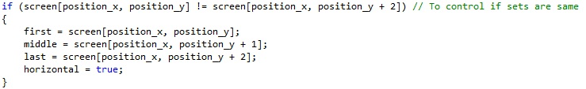

We used a funtion for time control and this function is called every second and does not wait any process to show information about time
Here it is called in main function and 1000 means 1 second

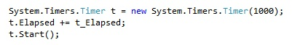

3.2. Functions
Give list of functions and parameters.

Initial conditions of parameters ;

string set_elements = "ABCDEFGH";
bool timeflag = true;
int result = 0;
char first, middle, last;
bool vertical = false, horizontal = false;
int delete_position_x, delete_position_y;
int score = 0;
int round = 1;

Here is the function for time

static void t_Elapsed(object sender, System.Timers.ElapsedEventArgs e)

3.3. Algorithms
Explain important algorithms and solution strategies in the project with code extracts. Use flowcharts if necessary.
Member | Algorithm/Solution strategy
Berkay Türkgeldi | When union operation is applied, it takes all elements from first set and second set but it should not take intersection elements twice. It is controlled loops and if statements and other operations are also parallel logic with this
Deniz Arslan | When sets are operating randomly, it is used two dimentional array and at first it is determined length of the set and then it is determined the sets’ number of elements in for loops. In outer loop, it is also checked if randomly element have already constructed, it takes different random elemet
Anıl Teke | When ‘X’ moves, it controls if there is a wall, it does not do anything. Otherwise, it controls if the place is space, it moved that place. If not, it controls if there are at least two character, it does not do anything, else it moves with the next character together
Ali Konya | When two of each set and operator signs are placed on board randomly, it is controlled that these symbols must have empty neighboor grids in 8 directions. It is important to game playability

4. Problems Encountered
Member | Problems and Solutions
Berkay Türkgeldi | When the sets are generated, same values could be in same set
Deniz Arslan | To fit whole the characters into the game area somtimes is not possible. So if there is no much space to allocate the remaining characters, the program goes to infintive while loop.
Anıl Teke | An expression could contain two same set but in game rules, it is not allowed
Ali Konya | When we construct 3 element expressions, the expression disappear but the table model become deformed

5. Conclusions
Summarize your work, describe what you have learned from the project both technically and socially.

Tecnically, we have learned how to use time control in our projects. Also, we used two dimentional array for set elements and we implemented it. At the same time, we have learned how to implement cursor movement keys and how to add text files in the board.
Socially, we apply distribution of tasks. The project improved our team work as well

6. References

ocw.mit.edu/courses/electrical-engineering-and-computer-science

7. Appendices
7.1. Poster/Web page of the Project
Give picture of poster or some key screens from web page.

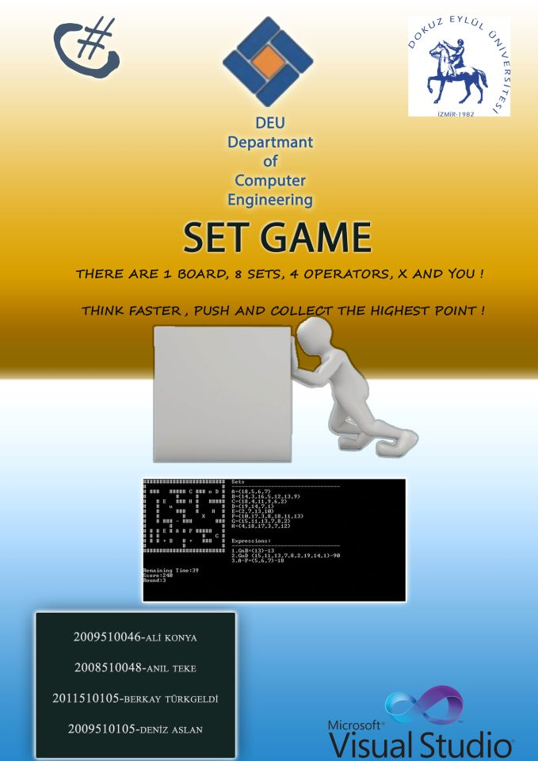

7.2. Code of the Project
Give clear, indented, fully commented code of your project.
